Summary of OpenMP:

- Openmp is a API for writing shared memory parallel applicaion in c, cpp or forton.
- It consist of compiler directives, runtime routines, environmental variables.
- In openmp memory model all threds are access the same memory, it is visible to all threds, the threds can store it in private memory but it is only visible to it only.
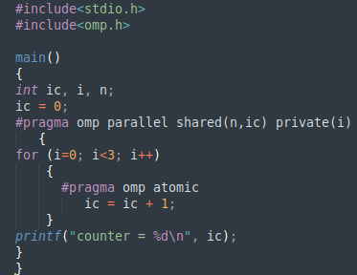

- The above program is a example program that how we use openmp. First we have to include the header file omp.h
- The #pragma is a compiler directive, an instuction in code that tells the compiler to perform specific actions, contols compilation details. It allows programers to influence how the compiler process code in a particular section without changing whole program.
- Omp parallel tell that the block should run in parallel by the team of threads.
- Shared means all threds can read and write the data simultaneously, unless protected through a specific openmp constuct. All changes made are visible to all the threads.
- Private means each thred has a copy of data, no other thred can access this data, changes only visible to only that thred.
- Omp atomic it tells that the comutation must be executed atomically.

